Configuring Oracle HTTP Server in a Standalone Domain

Starting the Configuration Wizard
To begin domain configuration, go to the ORACLE_HOME/oracle_common/common/bin directory on UNIX and ORACLE_HOME\oracle_common\common\bin on Windows and start the Oracle HTTP Server Configuration Wizard.
- On UNIX
- cd /<sid>/fmw/product/121/oracle_common/common/bin
- ./config.sh

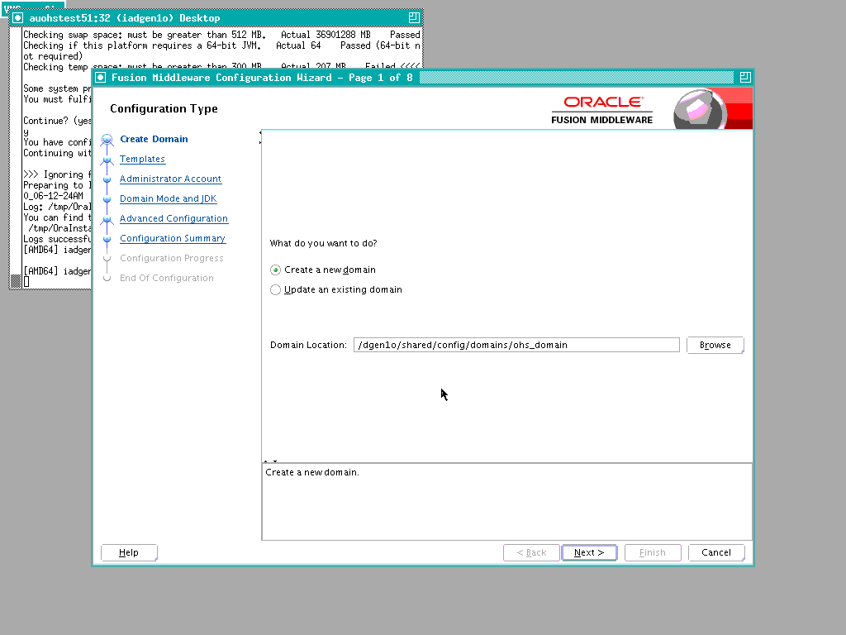

/<sid>/shared/config/domains/ohs_domain

click Next

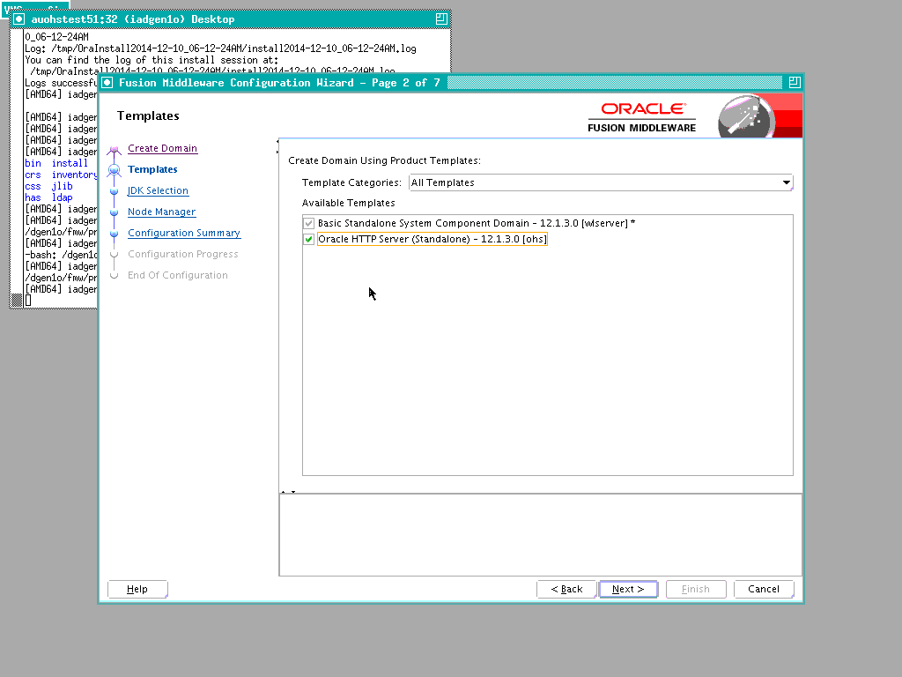
Select HTTP server standalone
Click Next

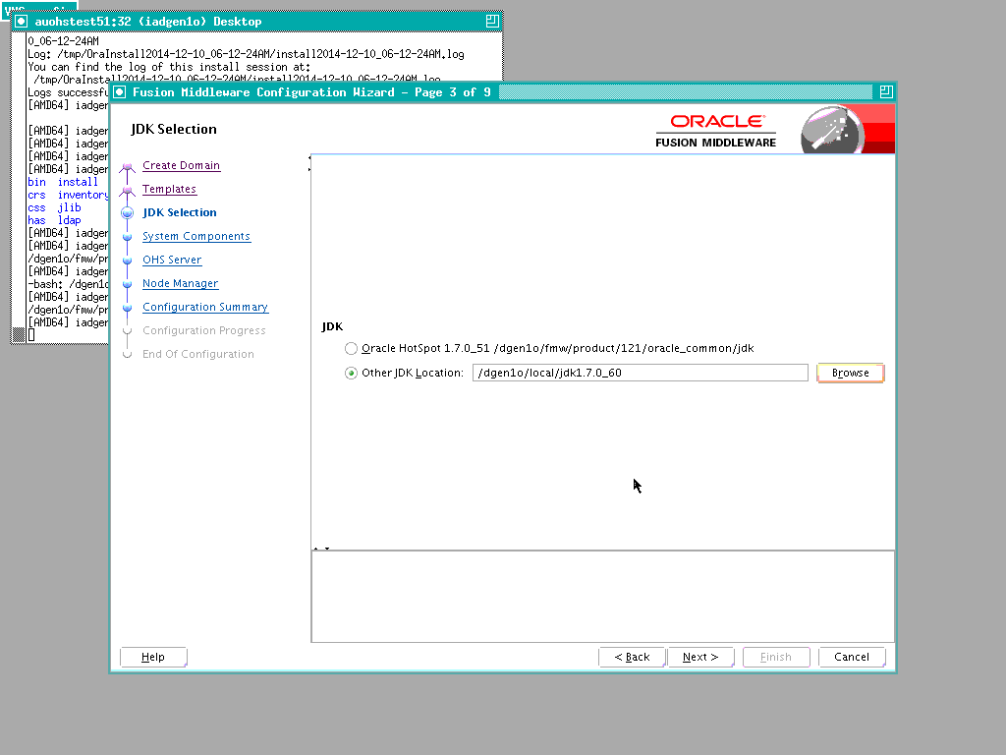

Select JDK already installed

click Next

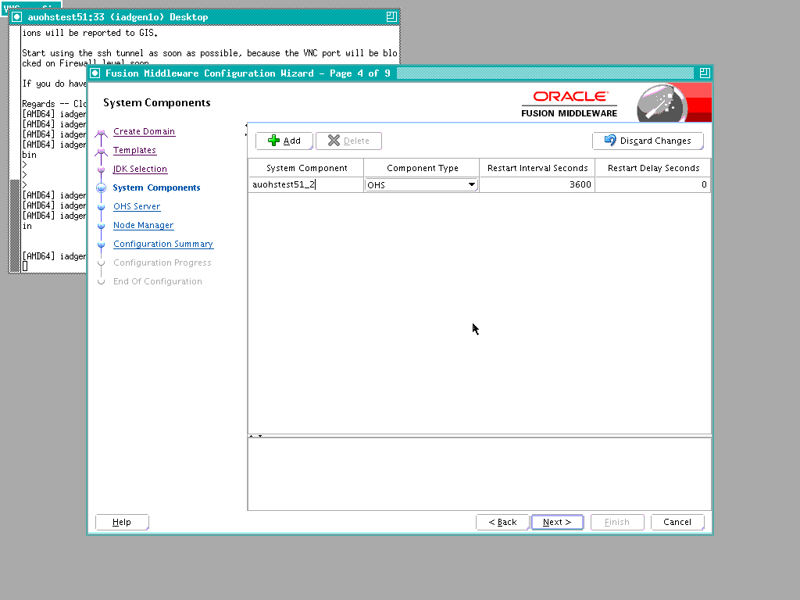

choose name of your MT server for 'system component'

click Next

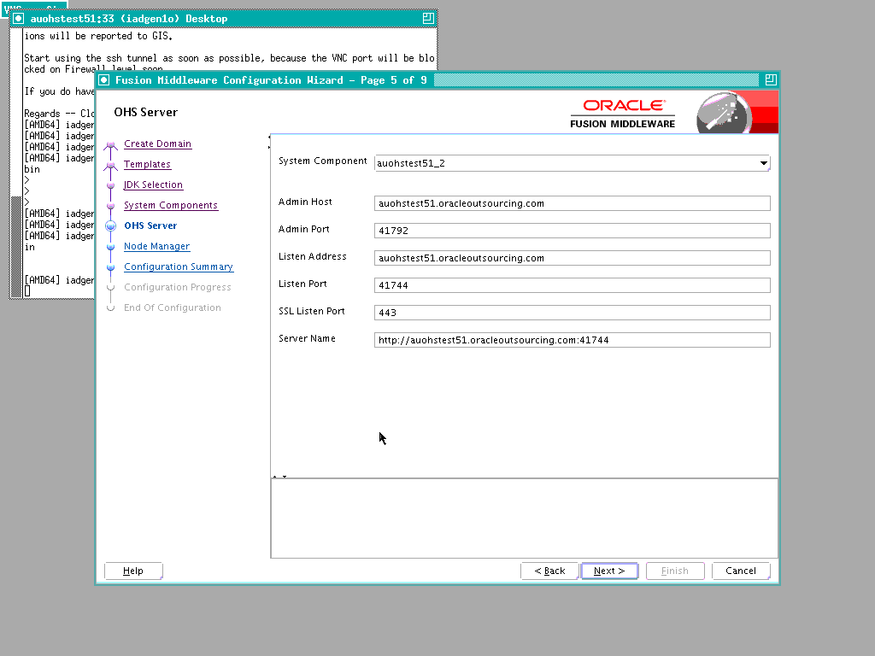

Fill in details

If NGI:
OHS_AdminPort=$013
OHS_ListenPort=$015
OHS_SSLListenPort=$014

If Legacy:
OHS_AdminPort=4BC43
OHS_ListenPort=4BC45
OHS_SSLListenPort=4BC44

Click Next

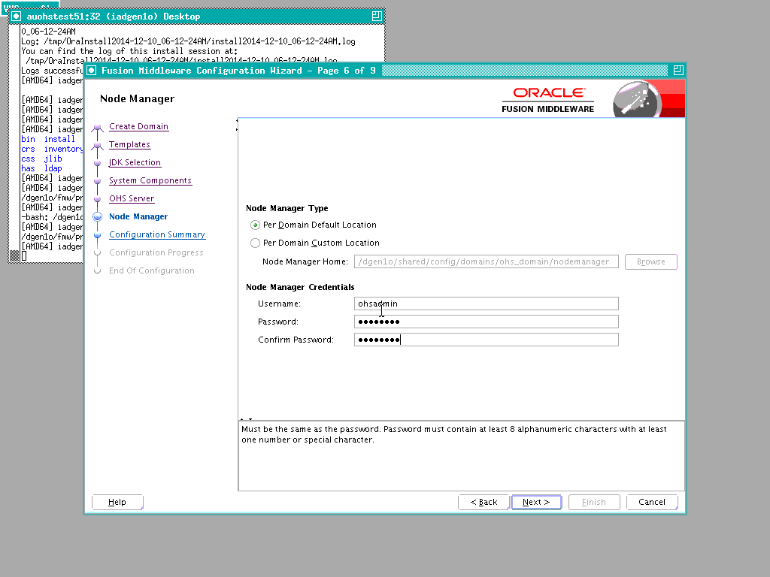

enter ohsadmin/ password
click Next

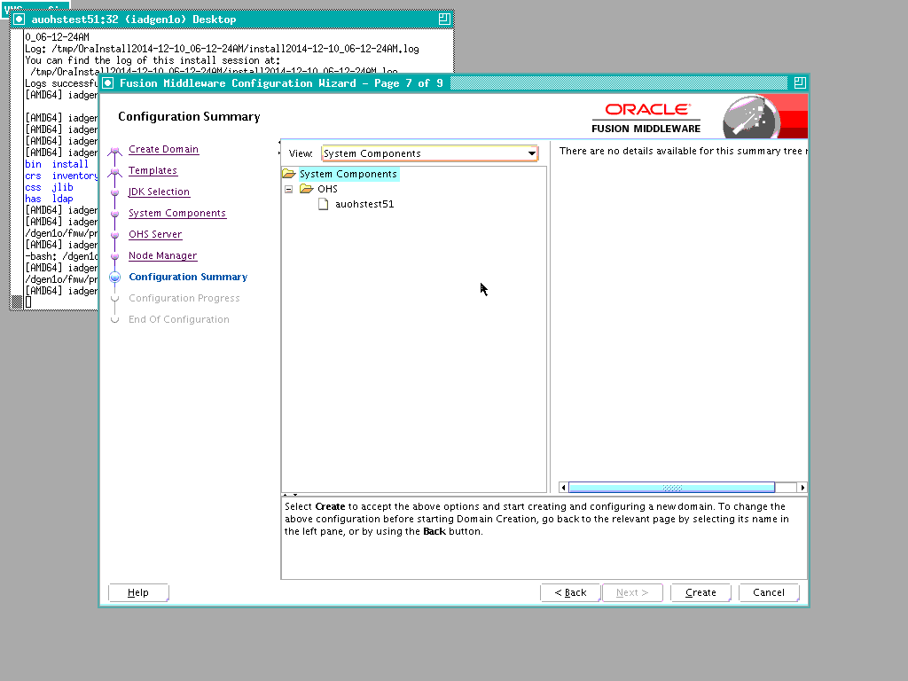

Click Create

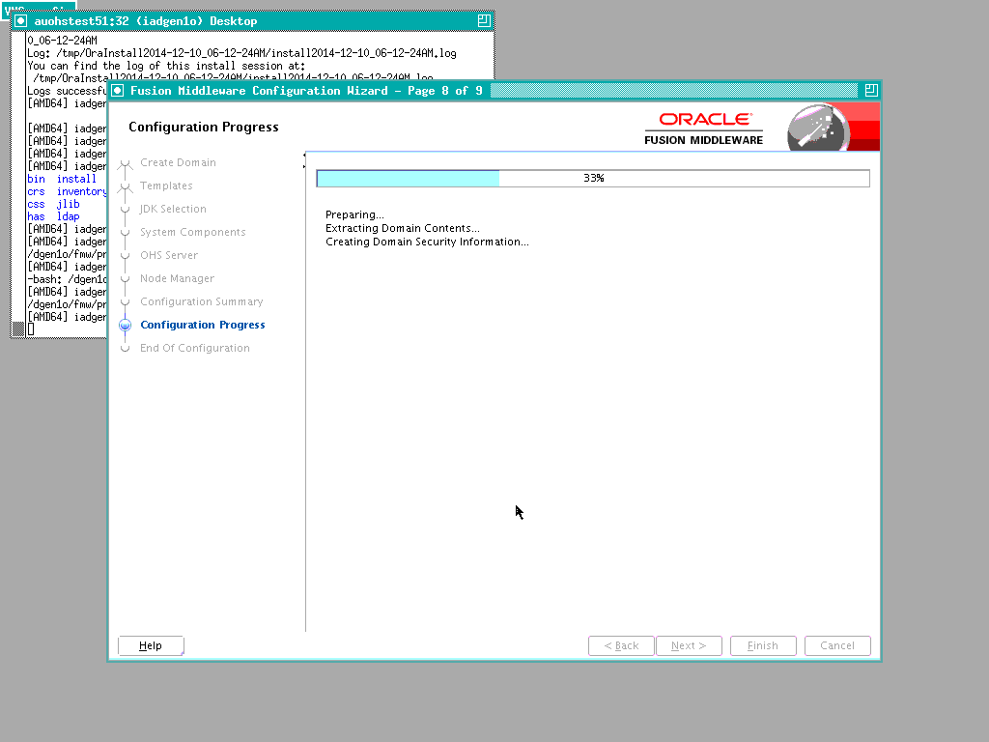

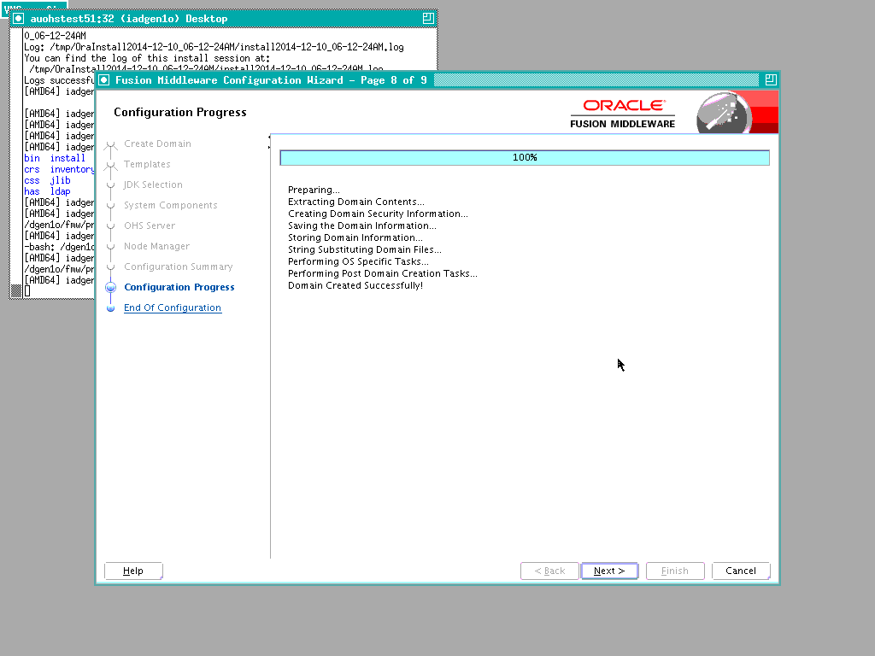

Click Next

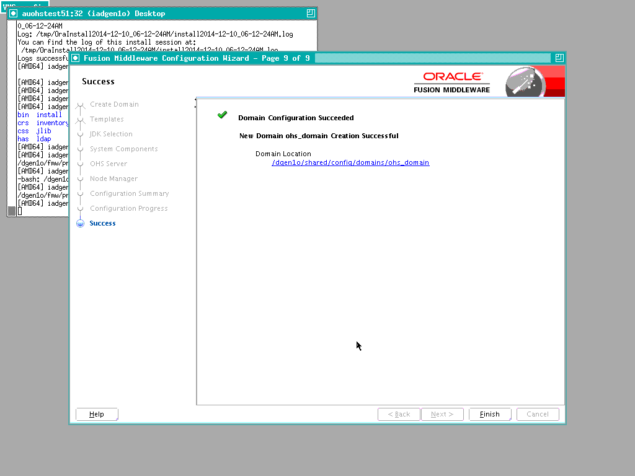

click Finish

Starting the Node Manager
cd /<sid>/shared/config/domains/ohs_domain/nodemanager
vi nodemanager.properties
- change values:

ListenAddress=Your MT server hostname including .oracleoutsourcing.com
ListenPort=4BC46

cd /<sid>/shared/config/domains/ohs_domain/config

vi config.xml
change
<listen-address>localhost</listen-address>
to
<listen-address>Your MT server hostname</listen-address>

add
<listen-port>4BC46</listen-port>

cd /<sid>/shared/config/domains/ohs_domain/bin

nohup ./startNodeManager.sh &

Configuring Oracle HTTP Server for the Managed Servers

vi /twrl6o/shared/config/domains/ohs_domain/config/fmwconfig/components/OHS/instances/vmohswrly171/httpd.conf

At the bottom of this file, paste the below lines.

LoadModule certheaders_module /<sid>/fmw/product/121/ohs/modules/mod_certheaders.so

NameVirtualHost *:4BC45

<VirtualHost *:4BC45>
ServerName https://sivaledemor12.oracleoutsourcing.com:443
ServerAdmin you@your.address
RewriteEngine On
RewriteOptions inherit
</VirtualHost>

<VirtualHost *:4BC45>
ServerName vmohswrly171.oracleoutsourcing.com:4BC45
ServerAdmin you@your.address
RewriteEngine On
RewriteOptions inherit
</VirtualHost>

vi /twrl6o/shared/config/domains/ohs_domain/config/fmwconfig/components/OHS/instances/vmohswrly171/httpd.conf

- Comment http_lock file line in httpd.conf file

- Find fcntl and replace with sysvsem in httpd.conf file

- Comment ssl.conf line in httpd.conf file

Goto /twrl6o/shared/config/domains/ohs_domain/config/fmwconfig/components/OHS/instances/vmohswrly171/mod_wl_ohs.conf

Update your respective mod_wl_ohs.conf entries.

Note: 1) comment DynamicServerList On from mod_wl_ohs.conf and always paste the content before </IfModule>

WLTempDir /dwrl6o/shared/config/domains/odi_domain/config/fmwconfig/components/OHS/instances/vmohswrly107/tmp/wl_dwrl6o

#Console /EM
<Location /em>
SetHandler weblogic-handler
WebLogicHost vmohswrly107.oracleoutsourcing.com
WeblogicPort 46701
WLProxySSL ON
WLProxySSLPassThrough ON
</Location>
<Location /console>
SetHandler weblogic-handler
WebLogicHost vmohswrly107.oracleoutsourcing.com
WeblogicPort 46701
WLProxySSL ON
WLProxySSLPassThrough ON
</Location>
<Location /consolehelp>
SetHandler weblogic-handler
WebLogicHost vmohswrly107.oracleoutsourcing.com
WeblogicPort 46701
WLProxySSL ON
WLProxySSLPassThrough ON
</Location>

Next: Create the following directory.
mkdir -p /dwrl6o/shared/config/domains/odi_domain/config/fmwconfig/components/OHS/instances/vmohswrly107/tmp/wl_dwrl6o

Next:
cp /twrl6o/shared/config/domains/ohs_domain/config/fmwconfig/components/OHS/instances/vmohswrly171 /httpd.conf /

to

/twrl6o/shared/config/domains/ohs_domain/config/fmwconfig/components/OHS/vmohswrly171

cp /twrl6o/shared/config/domains/ohs_domain/config/fmwconfig/components/OHS/instances/vmohswrly171 /mod_wl_ohs.conf

to

/twrl6o/shared/config/domains/ohs_domain/config/fmwconfig/components/OHS/vmohswrly171

Starting the Oracle HTTP Server Instance

/twrl6o/shared/config/domains/ohs_domain/bin/startComponent.sh `hostname -s` storeUserConfig

The username and password that were used for this WebLogic NodeManager connection are stored in /dgen1o/local/.wlst/nm-cfg-ohs_domain2.props and /dgen1o/local/.wlst/nm-key-ohs_domain2.props.
Connecting to Node Manager ...
Successfully Connected to Node Manager.
Starting server auohstest51_2 ...
Successfully started server auohstest51_2 ...
Successfully disconnected from Node Manager.

Validating Access Through Oracle HTTP Server

http://YourMTServername.oracleoutsourcing.com:4BC45/

